Airport Management System

Build Info
The folder includes the GUI and Backend files, as well as the airport.db provided. Here’s how to build and run.
- Open an IDE or any code editor (recommended: Visual Studio Code)
- Open an entire folder into the IDE/code editor, making sure the program is fully aware of the scope of the project.
- Go to the GUI folder, select Main_Menu.py, and simply run it from there (running any other GUI code snippet will jump straight into the program’s features. Clicking back would bring back to the Main Menu.)
- Have a blast! When you’re done, click “Exit”.

Design Patterns
Part of the attached file for submission is a picture of what the GUI would typically look like planned out on Microsoft Whiteboard. Mentioned earlier, the program is organized into Backend files (SQL files), and GUI files (Python files with tkinter package). For the GUI framework, we used tkinter package; back in Milestone 2, the project was coded in Python, and we discovered that we could easily build a GUI on top of this language using this package. It comes built in with the language, no extra installs. It was easy to setup. The reason the GUI is designed the way it is is that one of the teammates, when taking class notes, usually group their information into literally overlapping information blocks; that method was essentially carried over to the design of the GUI, and we branched off from there. Since most of the coding was based on the logic used in the last Milestone, a lot of the GUI menus are essentially big white output boxes that’ll output the results for you.

Quick Start Guide

Main Menu
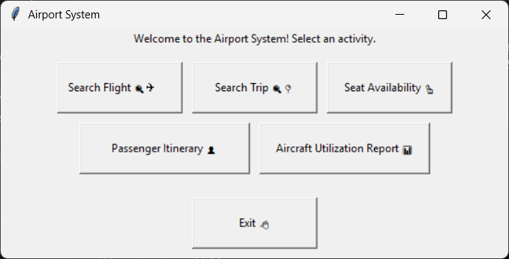
Pick any option you want to do!

Search Flight
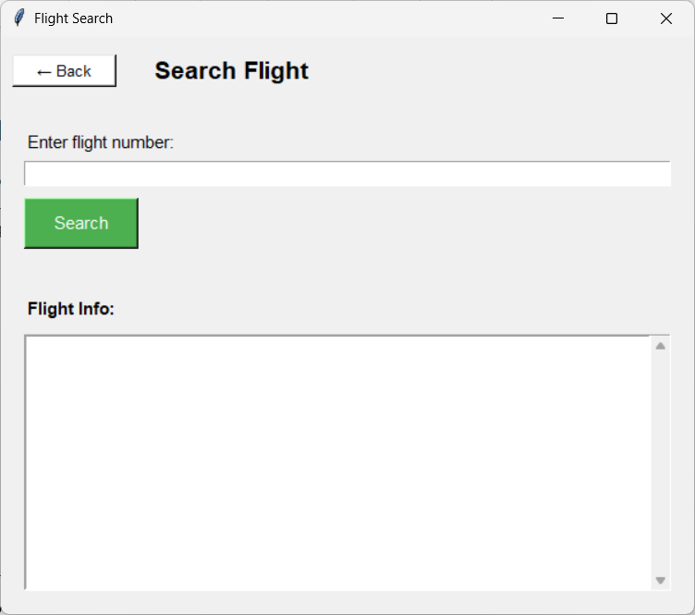
Enter any flight number (format: [letter][letter][four numbers]), and the results will show the information.

Search Trip
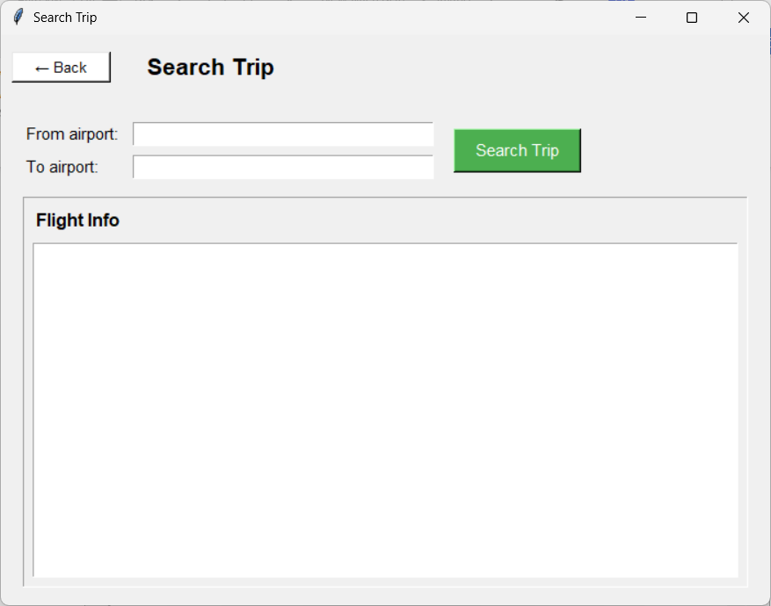
Choose any two airports (abbreviated by three letters), and you’ll be shown the possible paths you can take, whether single or multiple legs.

Seat Availability
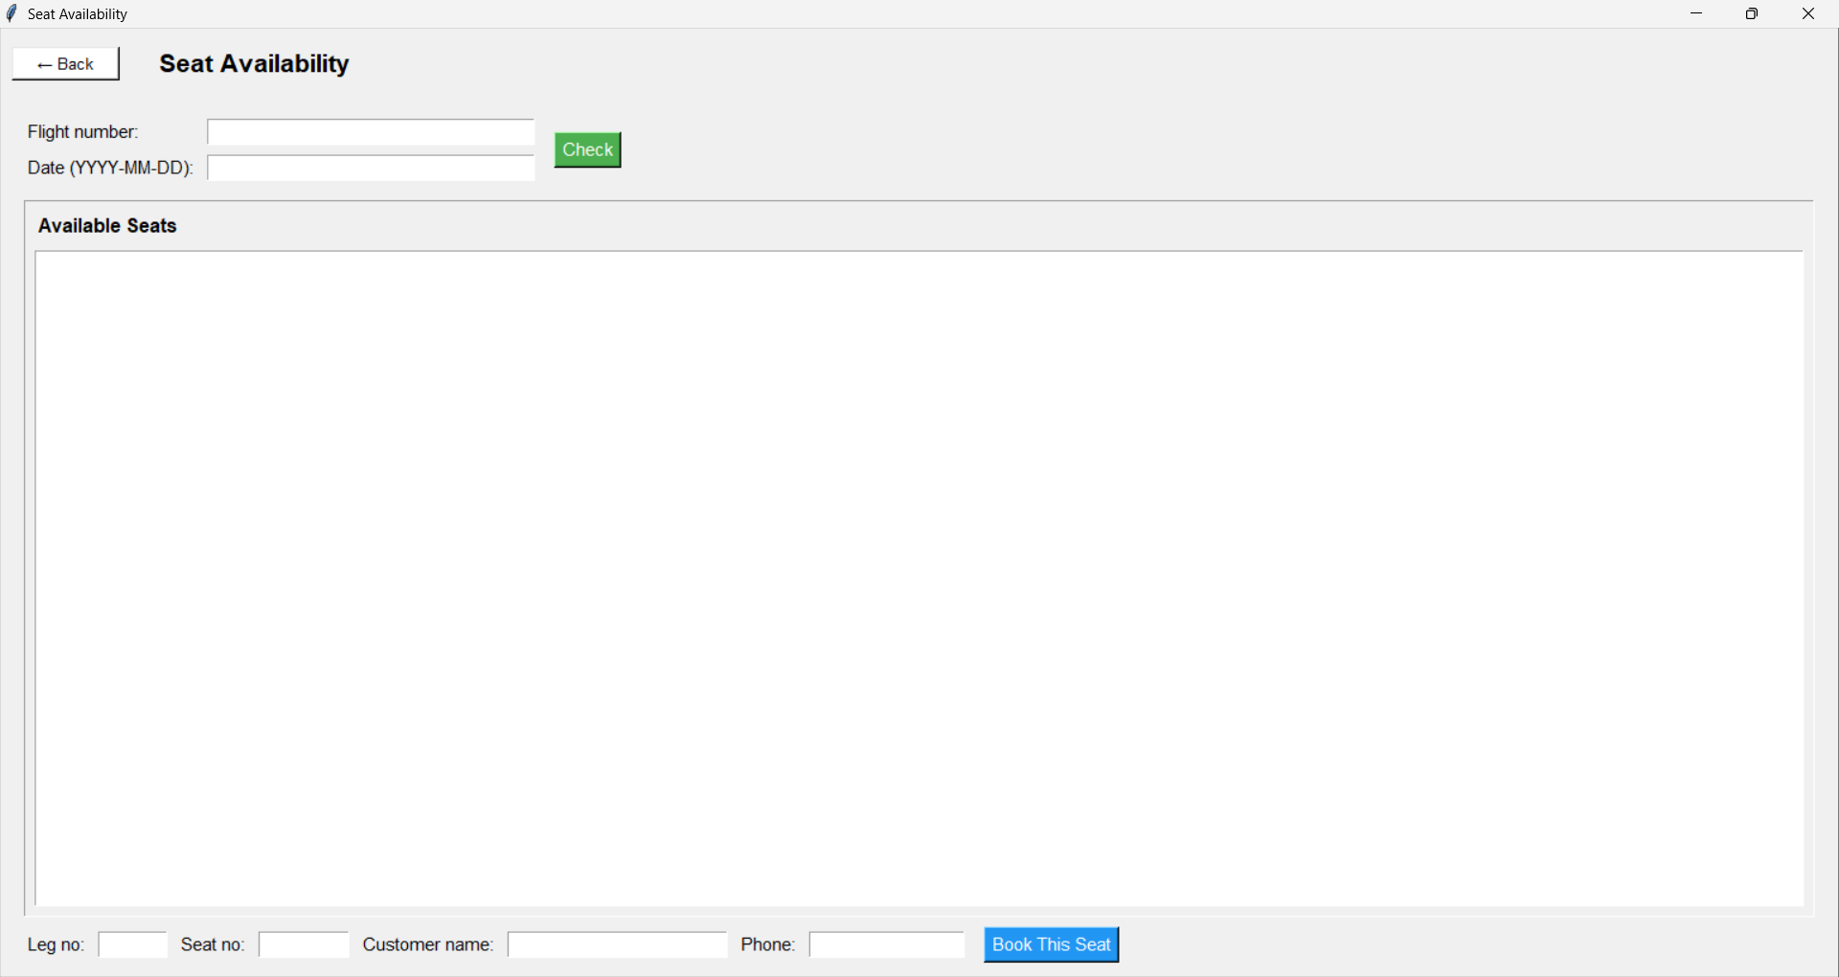
Pick a flight number and a date, and the results will show any available seats.
With the list shown, you can pick a leg and seat number, input your Name and Phone Number, and you can book that seat!

Passenger Itinerary
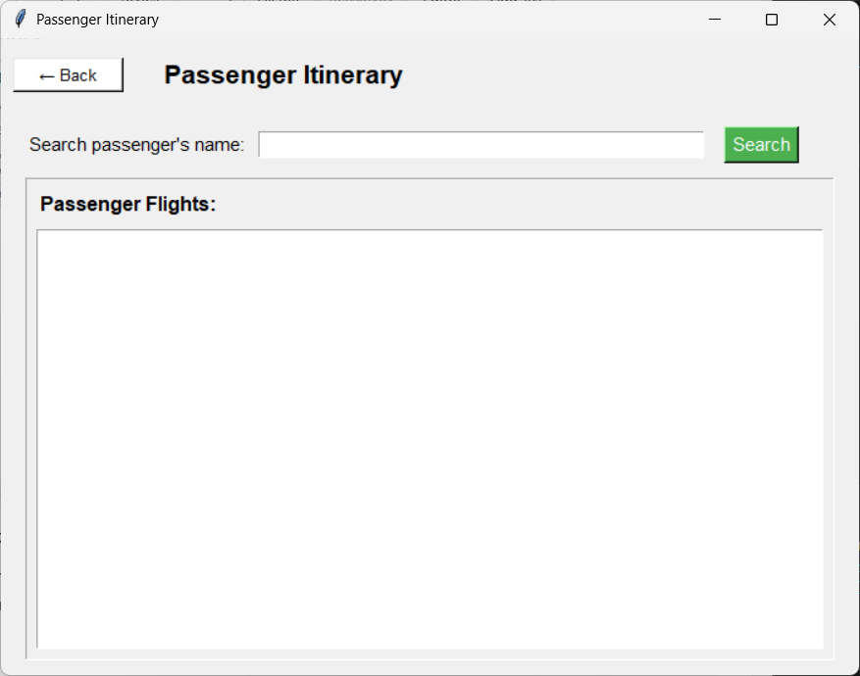
Search up a passenger name, and check out what flights they’re in!

Airport Utilization Report
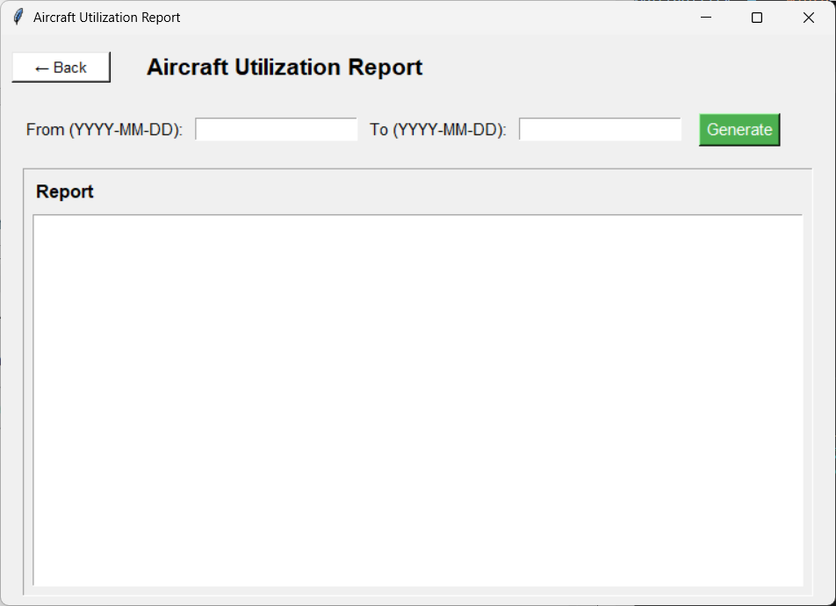
Select a date range, and get a list of all the flights information, from airports, seats, depart and arrival time, etc.

